Arduino (https://github.com/Seeed-Studio/Grove_Barometer_HP20x)
Software reset:
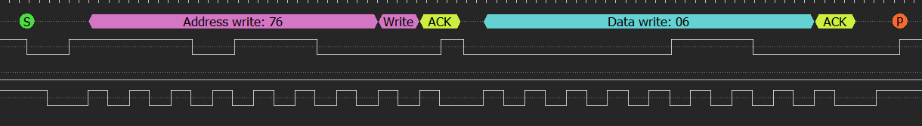
Is available?
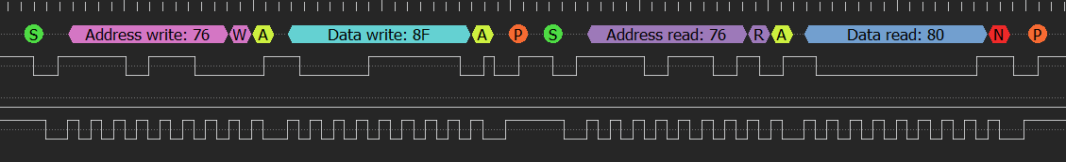
Start conversion:
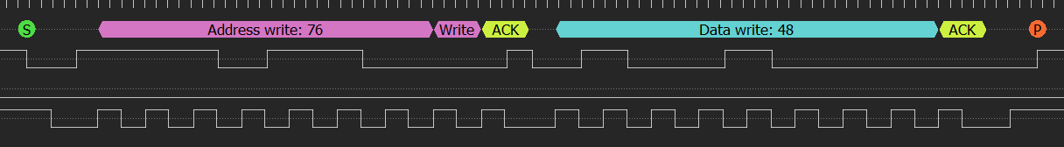
Ask for temperature and read it:
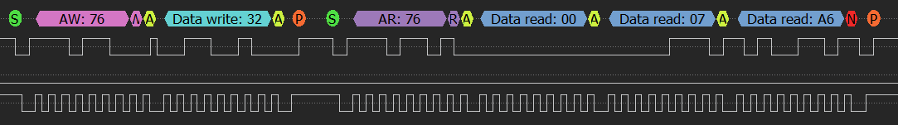
Start conversion:
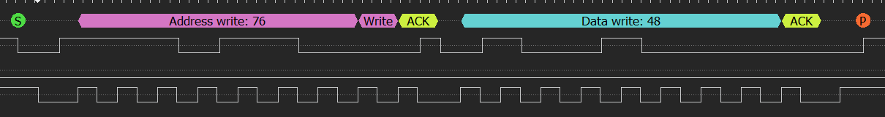
Ask for pressure and read it:
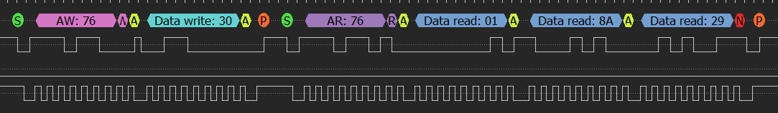
Ask for altitude and read it:
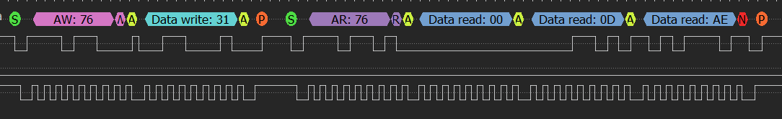
STM32 (based on https://www.hoperf.com/sensor/pressure_sensor/HP206C.html)
Compensate:
